**NAME**: MUHAMMAD SHARUL AIMAN BIN MAZLAN

**MATRICS NO.** : 2019273606

**CLASS**: KCS1104L

**HOMEPAGE:**

In this homepage section, viewers can read introduction of cryptocurrency and know the basics of them. Users also can interact with the buttons to skip to the certain tokens section that they want to know about, which is located on the right of this homepage. There is also gallery section on the right side such as fun fact of cryptos, so viewers can learn more knowledge of these digital currencies.

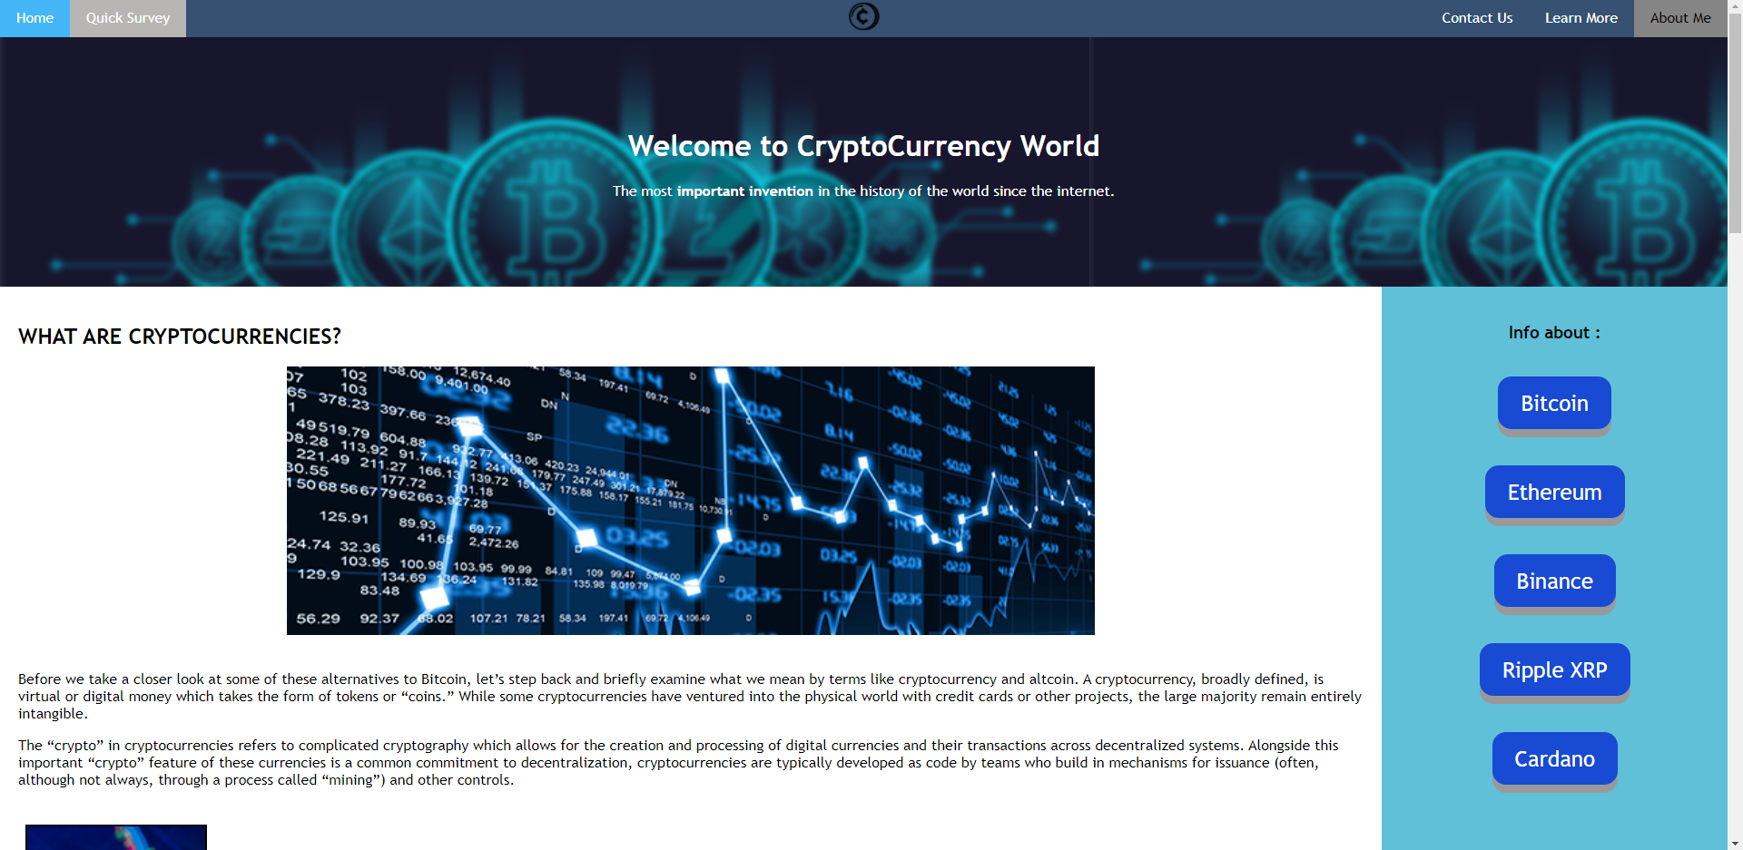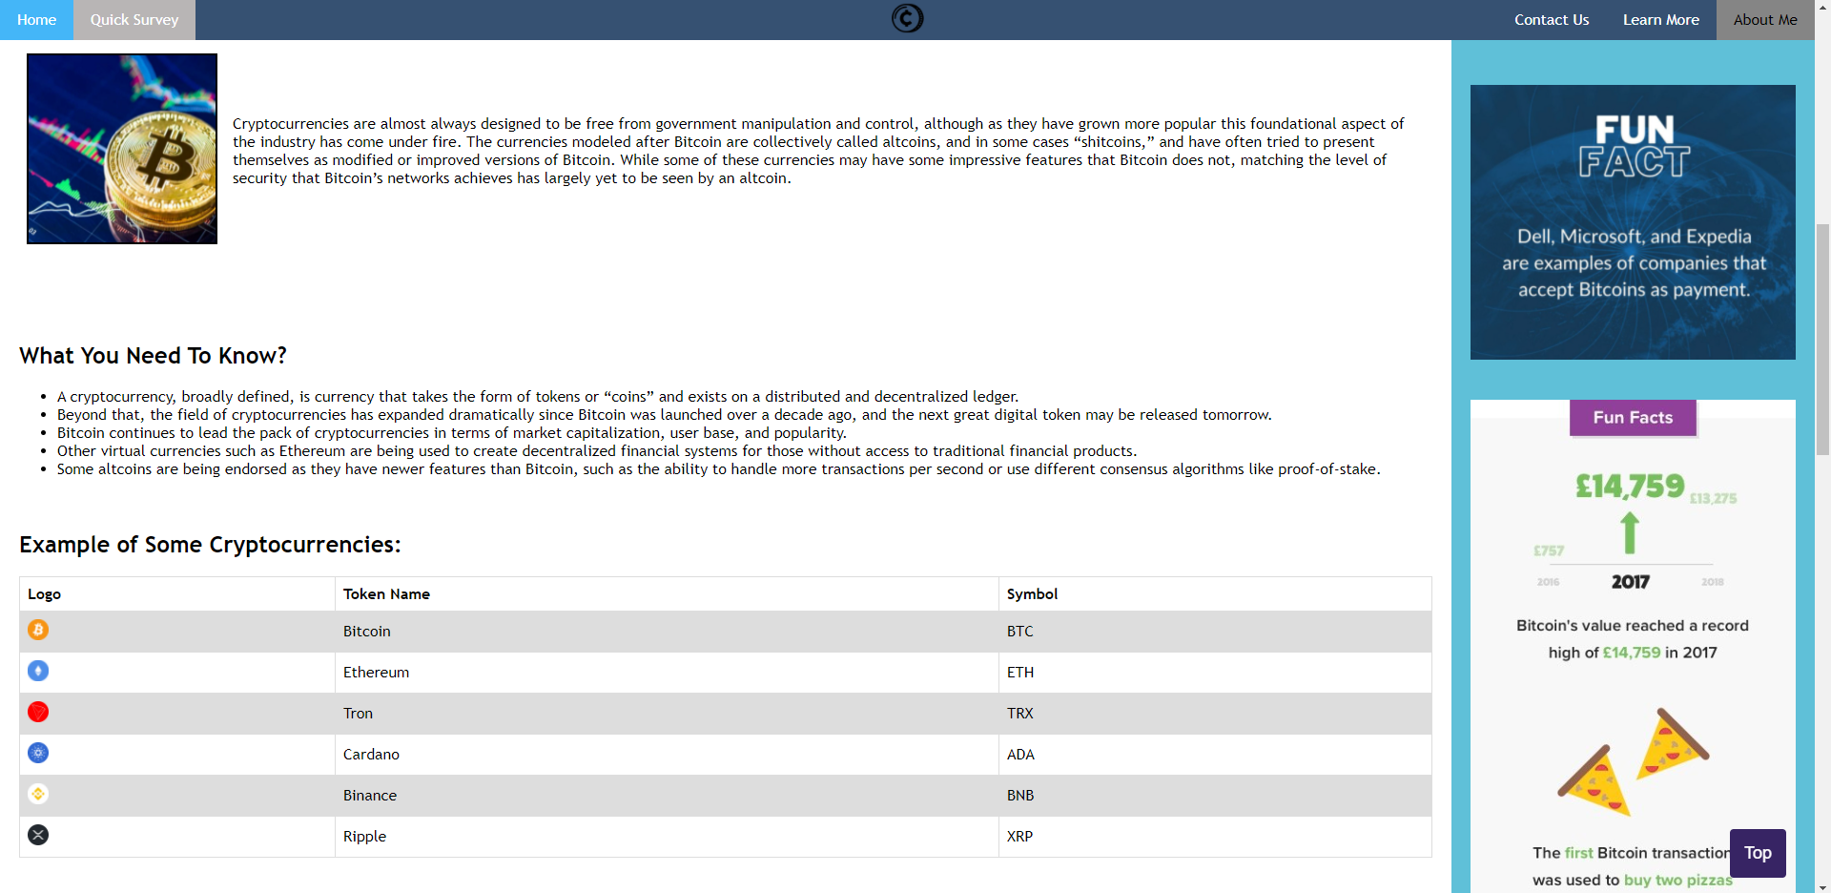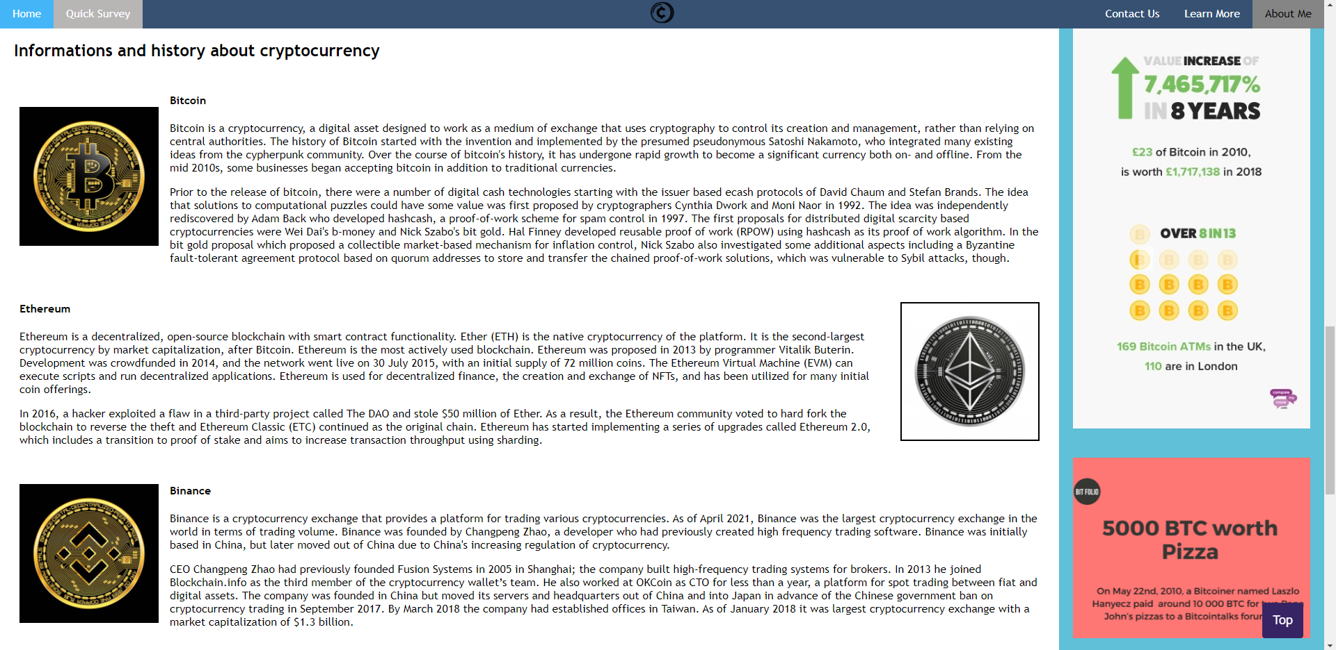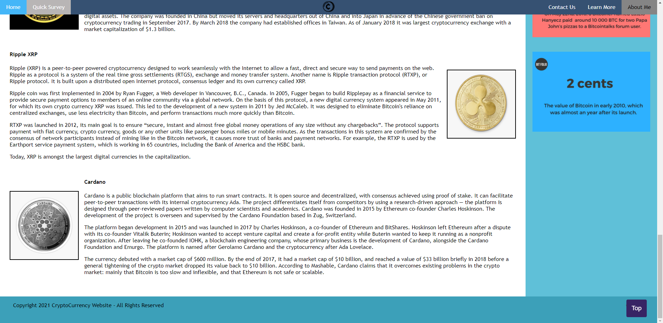

**QUICK SURVEY:**

Quick survey section is for viewers that want to participant in answering the questions related to cryptocurrencies. There are button, textbox, radio, checkbox, and selection menu in this page. Users can either ignore this page and continue reading this webpage or answer these question.

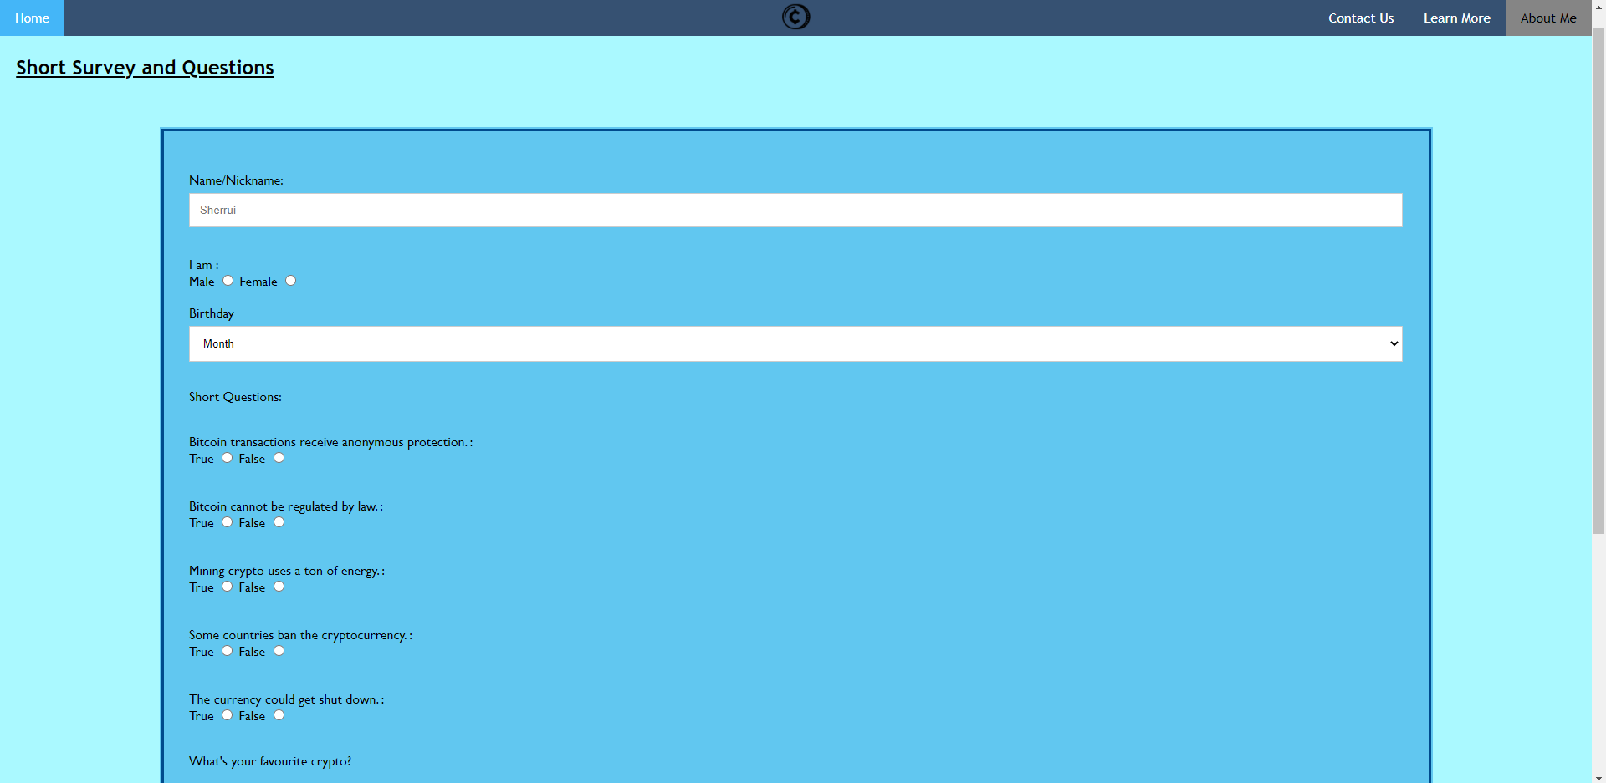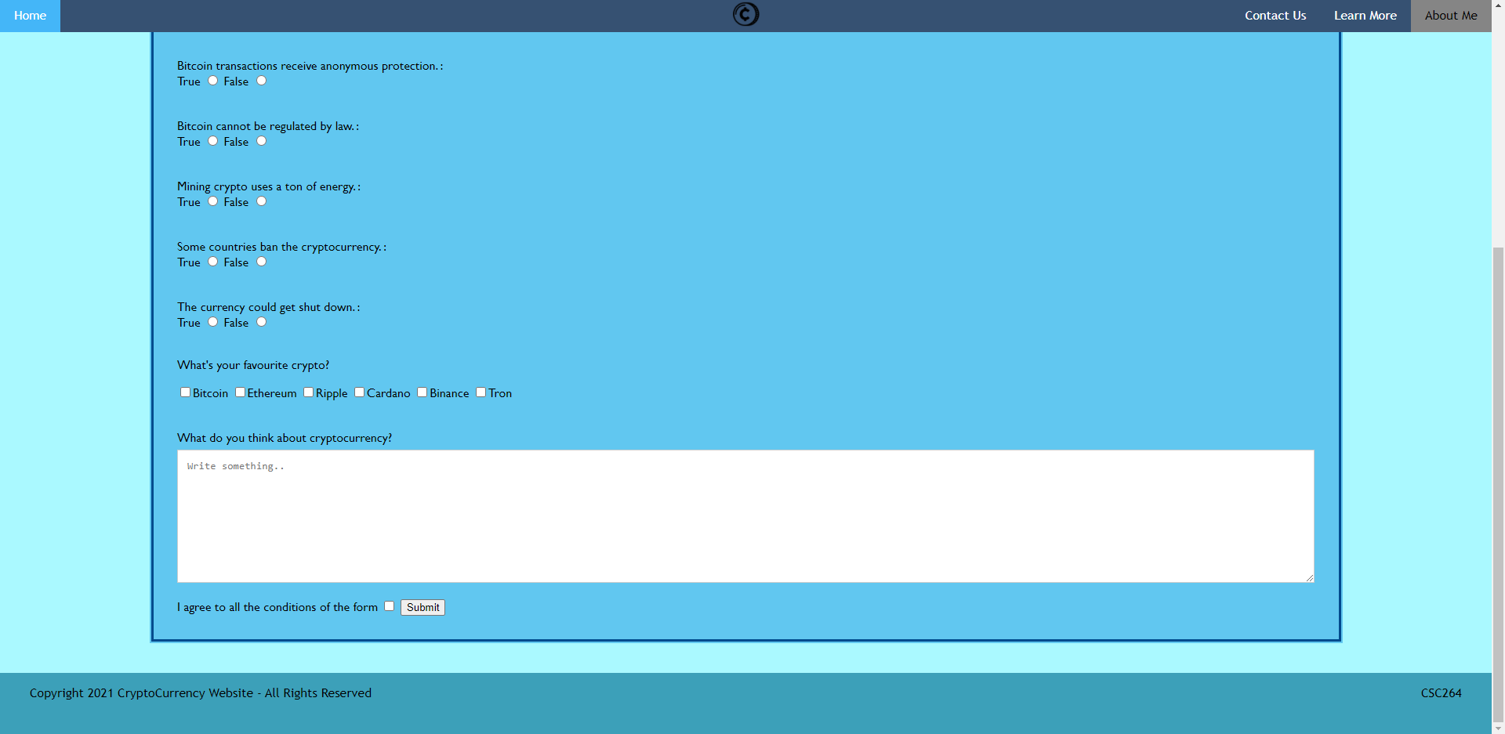

**CONTACT US:**

Other than that, viewers also can contact the creator of this page to get more info and update. They also can ask any questions related about cryptocurrency. On the right side,there is a media which is a image of awareness about cryptocurrency scam. Below the image, there is hyperlink which is direct users to report website just in case they know any organization or any suspicious activity related to cryptocurrency scam. So, they can create the report direct to that website.

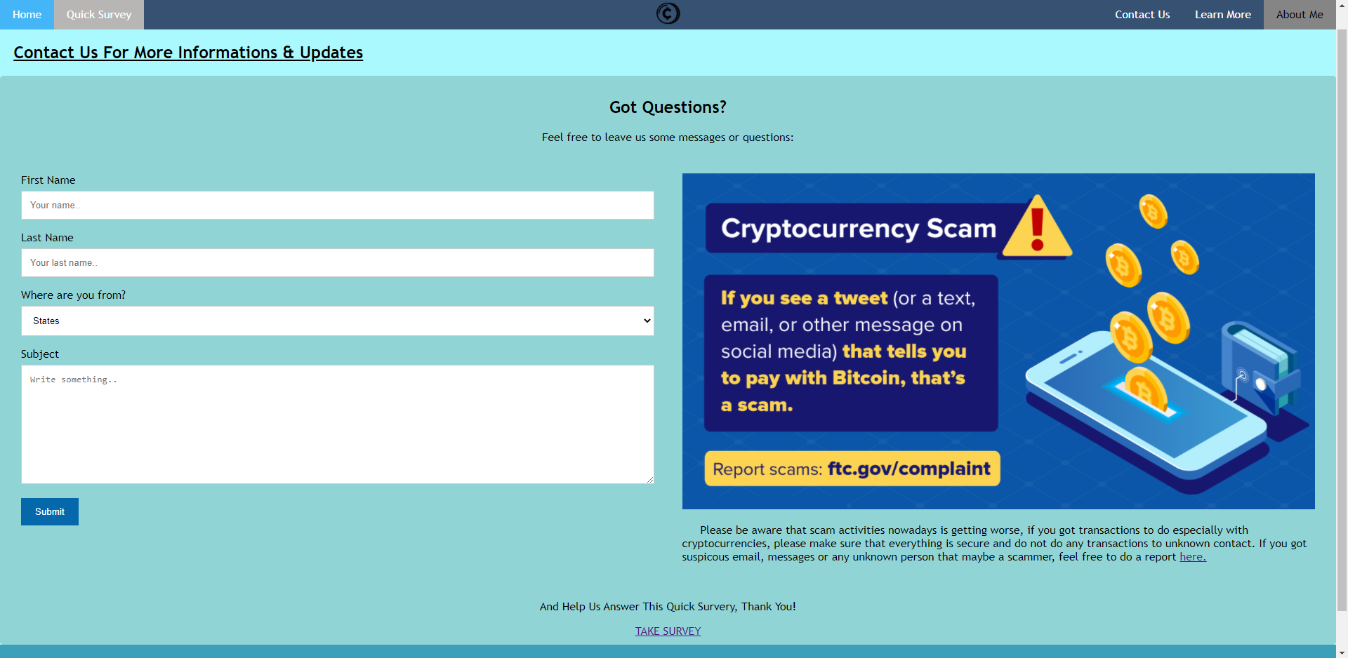

**LEARN MORE:**

Users can learn more in details about cryptocurrency especially about Bitcoin(BTC). There is a video on the left side of this page, and some details about it on the right side. Users can explore more on this website by scrolling down and read about history of bitcoin. From here, this website will give user the experience of rolling back in time where bitcoin was in beta and not release to public yet. On the bottom of this page, details about some creators of these tokens will be introduced.

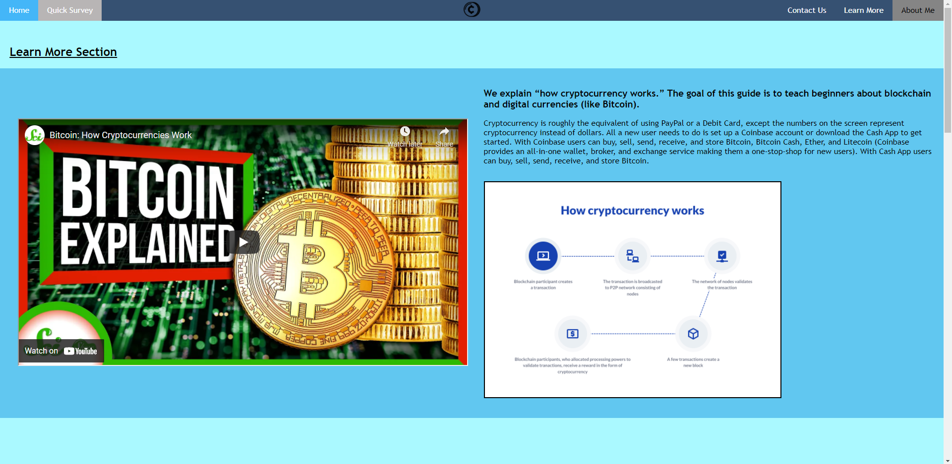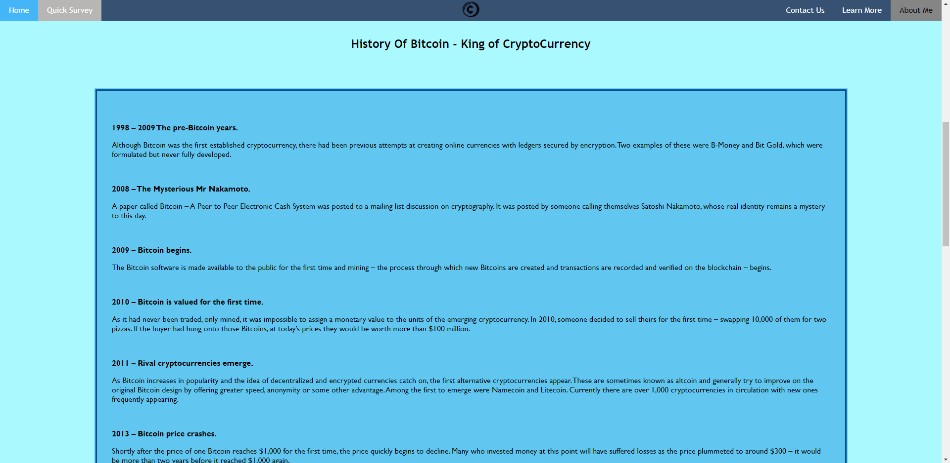

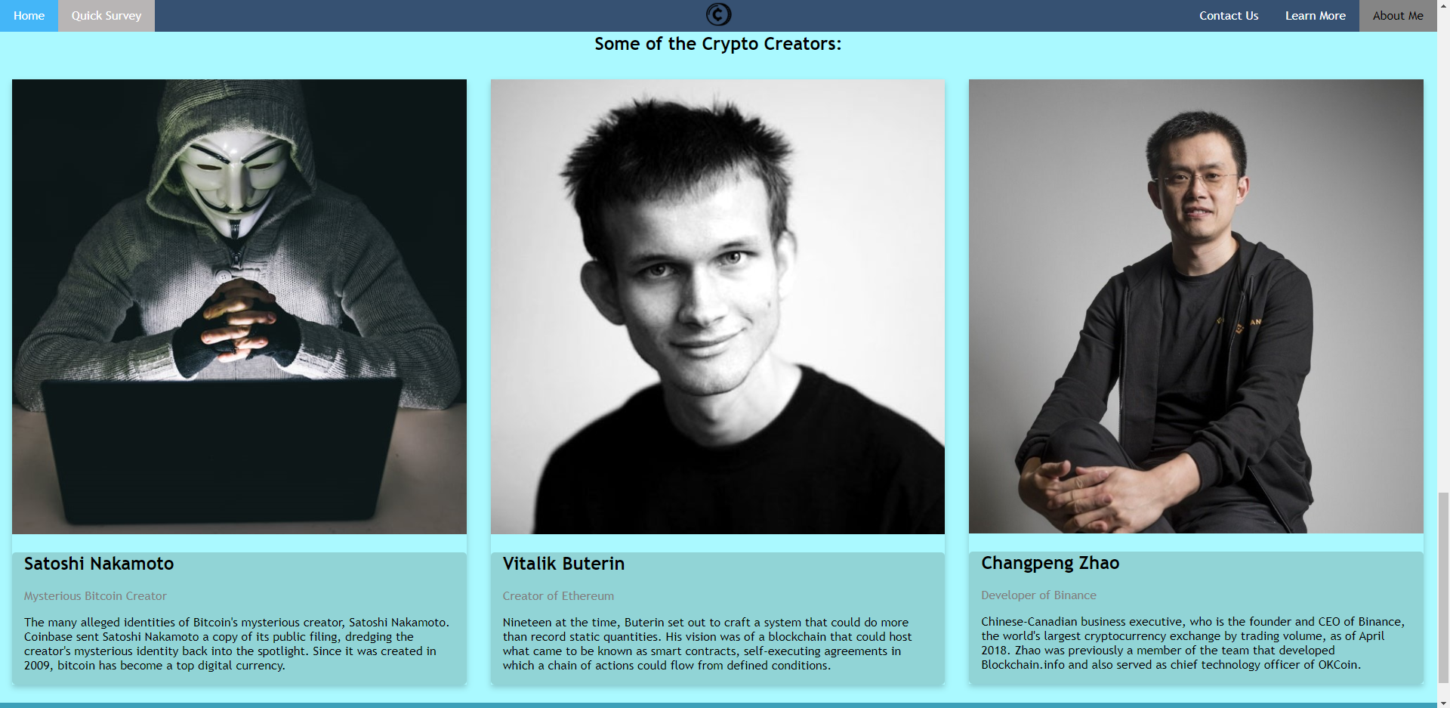

**ABOUT ME:**

This is about me page, which I will introduce myself, as a page creator and for this project. So, this is the last page for this website and that is all from me, thank you.

